**Lab 11**

Python program to convert entered bytes to bits

**def** **convertBytesToBits**(byteAmount):

**return** byteAmount\***8**

sUserBytes=raw_input("Enter byte amount to be converted to bits: ")

userBytes=int(sUserBytes)

bitAmount=convertBytesToBits(userBytes)

**print** ("%d bytes is %d bits"%(userBytes,bitAmount))

IDE screenshot

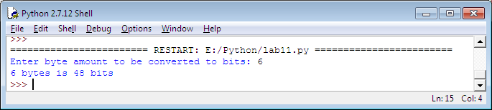

Command line screenshot

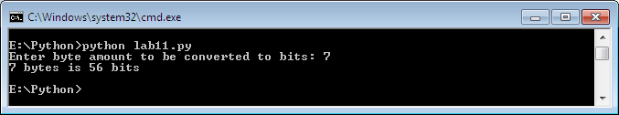

**Lab 11 Optional 1 – Currency conversion program**

inF=open('Book1.csv','r')

outF=open('convertedData.csv','w')

columnNames=inF.readline()

outF.write(columnNames)

**for** l **in** inF:

listRow=l.split(',')

dollar=float(listRow[**1**])*float(listRow[**2**])

formattedDollar="%.2f"%dollar

l=l.replace('?',formattedDollar)

**print** l

outF.write(l)

inF.close()

outF.close()

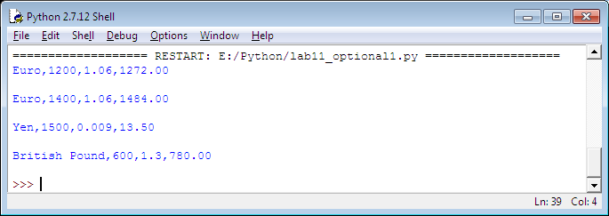

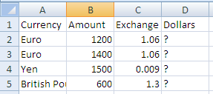

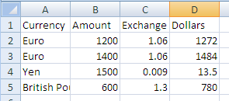

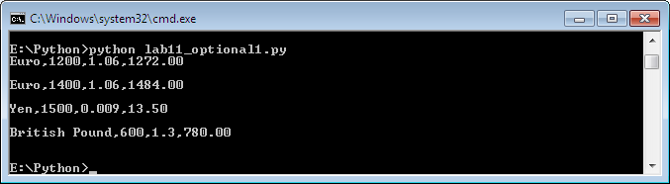

**Lab 11 Optional2 – Student Grader**

#open file

fo=open("students.csv","r+")

fo2=open("finalGrades.csv","w+")

**for** l **in** fo.readlines():

**print** "This is a line read from the file as string :", l

list=l.split(',') #this converts the line into a list

**print** "This is what the list looks like: ", list

id=list[**0**] # here we store the students's id

lab1=float(list[**1**]) # we convert string values to float data type

lab2=float(list[**2**])

lab3=float(list[**3**])

finalLabScore=(lab1+lab2+lab3)/**3.75**

finalProjectScore=float(list[**4**])\***0.20**

finalSurveyScore=float(list[**5**])\***0.05**

finalScore=finalLabScore+finalProjectScore+finalSurveyScore

letterGrade="n/a"

**if** finalScore>**90**:

letterGrade="A"

**elif** finalScore>**80**:

letterGrade="B"

**elif** finalScore>**70**:

letterGrade="C"

**elif** finalScore>**55**:

letterGrade="D"

**else**:

letterGrade="F"

line="%s, %.2f, %s**\n**" %(id,finalScore, letterGrade)

**print** "This is the Students Id, Numerical Score, Letter Grade: ",line

fo2.write(line)

**print** "========================================"

#close opened file

fo.close()

fo2.close()



